**24th IARU REGION 1 / EUROPEAN ARDF Championship 2024**

**(together with ARDF World Cup Black Sea 2024)**

**Primorsko, Bulgaria**

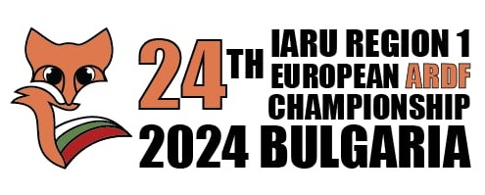**Bulletin 3**

**8 August 2024**

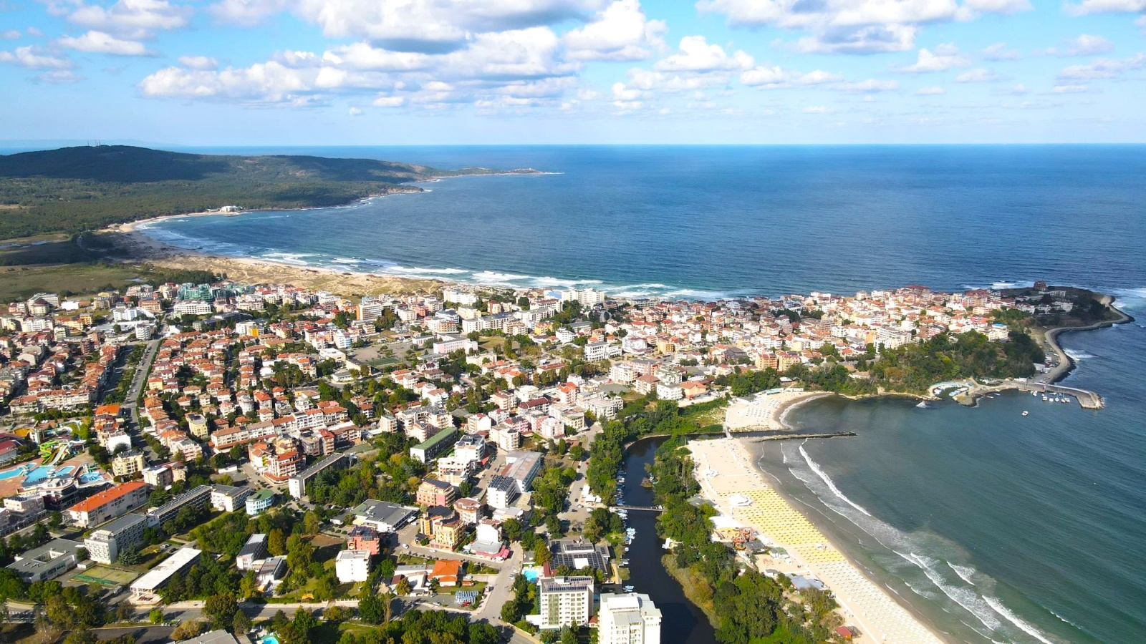

**Dear ARDF friends,**

Please find below additional information about the events planned to take place in August – September 2024 in Primorsko, Bulgaria.

**1. Summary of entries received**

By the time of issue of this Bulletin, the received Letters of Intent and the declared numbers of competitors are as following:

**24th IARU – R1 / European ARDF Championship 2024:** In total 223 competitors from Austria, Belgium, Bulgaria, Czechia, Estonia, Finland, Germany, Hungary, Kazakhstan, Lithuania, Moldova, Norway, Poland, Romania, Serbia, Slovakia, Slovenia, Sweden, United Kingdom and Ukraine,

**World Cup Black Sea 2024**: In total 72 competitors from Austria, Bulgaria, Czechia, Hungary, Moldova, Romania, Slovakia, Sweden, United Kingdom and Ukraine.

We would like to thank the societies from the above countries and in the same time to make **a special appeal to all other** potential participants. **Please send your Letters of Intent as soon as possible** (A sample of Letter of Intent is available in Bulletin 1/2 <https://ardf2024.eu/>). **It’s your last chance**. Remember that the competitions are to be held during the active summer tourist season and the hotels may become fully booked, if not by participants in the ARDF competitions, but by casual tourists.

We would also like to make a note to the Rules for Championships in Amateur Radio Direction Finding, Item A 6.3:

*In order for IARU Region 1 Member Societies to be allowed to start as official competitors in an international IARU ARDF Championship, they* ***must have fulfilled all their financial obligations to Region 1*** *by the end of the month prior to the month in which the Championships take place. If requested, facilities will be provided to accept outstanding fees together with payment of the championship fee and expenses.*

**2. Jury members**

Chairman of the Jury

Dušan Ćeha YU1EA

Jury Members

1. Franci Žankar, S57CT
2. Igor Lazarev, US0VA
3. Stipe Predanić, 9A5SP
4. Dejan Grozdanovic, YU1AS
5. Pavel Babeu, YO9TW
6. Remigius Masilionis, LY1RM
7. Karl-Heinz Schade, DL7VDB

Siting Referee  
 Viktor Tsenkov, LZ3NN

Technical Director

Stoyan Topalov, LZ1STQ

**3. Detailed program of the competitions**

**World Cup Black Sea 2024**

**28 August, Wednesday** – till 14:00 arrival, accommodation, testing the equipment 15:00-15:30, Sprint, walking to the start 16:00, first start 17:00;

**29 August, Thursday** – Classic 144 MHz (all categories), transportation by bus to the start 08:30, first start 09:30;

**30 August, Friday** – Classic 3.5 MHz (all categories),transportation by bus to the start 08:30, first start 09:30;

**31 August, Saturday** – Foxoring, transportation by bus to the start 08:30, first start 09:30;

*The busses will be parked near* ***Hotel Forest Beach.***

**24th IARU-R1 / European ARDF Championship 2024**

**1 September, Sunday** – arrival, accommodation, testing the equipment 15:30-17:30, official opening 18:30;

**2 September, Monday** – Sprint, transportation by bus to the start 08:00, first start 09:00;

**3 September, Tuesday** – Classic 1, transportation by bus to the start 08:00, first start 09:00;

Classic 1:

3.5 MHz: M19, M21, M40, W19 and W21;

144 MHz: M50, M60, M70, W35, W45, W55 and W65.

**4 September, Wednesday** – rest day / beach time;

**5 September, Thursday** – Classic 2, transportation by bus to the start 08:00, first start 09:00;

Classic 2:

3.5 MHz: M50, M60, M70, W35, W45, W55 and W65;

144 MHz: M19, M21, M40, W19 and W21.

**6 September, Friday** – Foxoring, transportation by bus to the start 08:00, first start 09:00,

*The busses will be parked near* ***Hotel Forest Beach.***

*The busses from* ***Hotel Forest Beach*** *to the finish (for visitors) every day at 09:30.*

**7 September, Saturday** – departure

**4. Details of the terrains**

**SPRINT**

|  |  |
| --- | --- |
| **Terrain form** | Flat to moderately steep terrain. |
| **Vegetation** | Coniferous forest |
| **Runability and visibility** | Mostly excelent, but reduced in some places with denser vegetation. |
| **Roads and paths** | Good network of paths and roads. |
|  |  |

**CLASSICS**

|  |  |
| --- | --- |
| **Terrain form** | Moderately steep terrain. |
| **Vegetation** | Coniferous forest. |
| **Runability and visibility** | Various vegetation – from forest with excellent runnability to impassable forest. |
| **Roads and paths** | Good network of paths and roads |
|  |  |

**FOXORING**

|  |  |
| --- | --- |
| **Terrain form** | Moderately hilly terrain. |
| **Vegetation** | Coniferous forest. Some open and semi open lands. |
| **Runability and visibility** | Various vegetation – from forest with excellent runnability to impassable forest. |
| **Roads and paths** | Good network of paths and roads |
|  |  |

**5. Size of the maps (not the paper on which it is printed), scales and vertical contour intervals of the maps for each competition.**

Sprint: 1:5 000, h=5 m, Landscape, 27 cm x 20 cm;

Classic 1 - 1:10 000, h=5m, Landscape, 28 cm x 20 cm;

Classic 2 - 1:10 000, h=5m, Landscape, 28 cm x 20 cm;

Foxoring - 1:10 000, h=5m, Portrait, 20 сm x 28 cm.

**Maps for all competitions will be printed on waterproof paper.**

**6. The exact location of the finish point of each competition**

Location of the finish points:

Sprint 42.287724 N , 27.753578 E

Classic 1: 42.238184 N, 27.725666 E

Classic 2: 42.236328 N, 27.717901 E

Foxoring: 42.291947 N, 27.619741 E

**7. Address, phone number and e-mail address of the competition office**

Competition office during all competitions:

Primorsko, Hotel Forest Beach

Phone number:

+359 889 318 297 (Viktor Tsenkov, LZ3NN);

E-mail address:

[Lz3nn@abv.bg](mailto:Lz3nn@abv.bg)

**8. Internet site of the Championships**

[www.ardf2024.eu](http://www.ardf2024.eu)

More information will be announced in Bulletin 4.

We are looking forward to meeting you soon in Primorsko!

**Bulgarian Federation of Radio Amateurs**