**Dear ARDF friends**,

Once again - welcome to Bulgaria!

Bulgarian Federation of Radio Amateurs (BFRA) holds the record for the number of World and R1 ARDF Championships organized. Moreover, we have never had the slightest hesitation in taking over the organization in case the established host backed out at the last moment, leaving us very little time for the difficult organization. We have never emphasized the financial result. The only important thing for us is that the competition takes place at the highest level, with impeccable organization and leaves pleasant memories for all participants.

It's now time for the next IARU Region 1/European ARDF Championship.

BFRA is proud to host it

**24th IARU REGION 1 / EUROPEAN ARDF Championship 2024**

**(together with ARDF WORLD Cup Black sea 2024)**

**Primorsko, Bulgaria**

**Bulletin 1 / 2**

**1 May 2024**

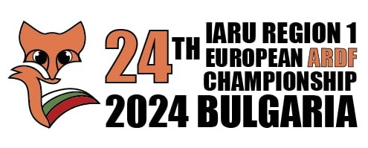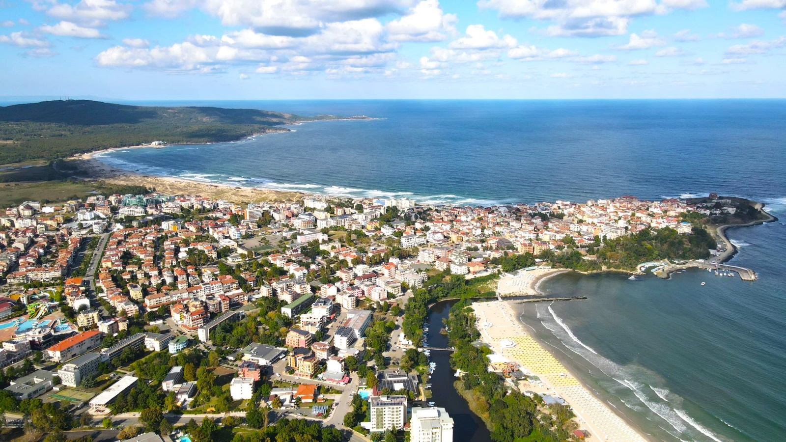

**Venue**

The Championship will be held in Primorsko, situated at the Black Sea coast, 52 km south of Burgas. Primorsko is a relatively small town (population 3000), but one of the well-known Bulgarian sea resorts. Many factors make it a preferable destination for the summer vacation – ecologically pure region, 10-km-long beach, active nightlife.

The weather in Primorsko at the beginning of September is almost without exception sunny with still summer maximum temperatures of 25 - 26 degrees C. Early in the morning at sunrise, the minimum temperatures are 15 - 16 degrees C. Afternoons are perfect for the beach.

**Second event**

Besides the Championship, between 28 and 31 August 2024, another ARDF competition, so-called **with ARDF WORLD Cup Black sea 2024**, will be held in Primorsko, too, but on different terrains.

Please **see below for all details**. All the information will be available very soon in <https://ardf2024.eu/>

**Transportation**

Some of the teams travel, as tradition, by their own bus/cars. The rest may select their final destination among Burgas Railway Station, Burgas International Airport (70 km away from the venue) or Varna International Airport (180 km away from the venue). The distance from Sofia Airport to Primorsko is 424 km. The organizers will provide transfers to the venue and back **upon request**, made **at least 10 days in advance**. The price of the transfer per person will be calculated according to the number of applicants..

**Accommodation**

The accommodation for both events will be organized in Primorsko club, Hotel Forest Beach ****, one of the best hotels in Primorsko <https://forestbeach.bg/bg>

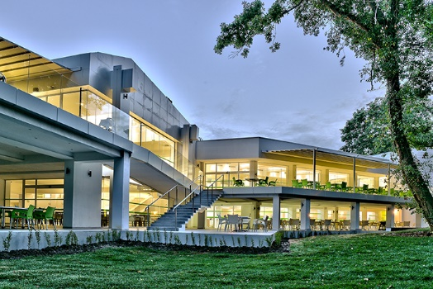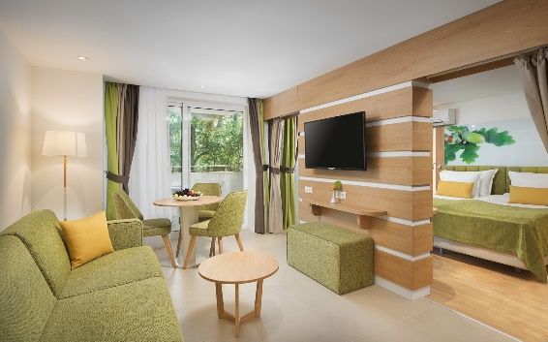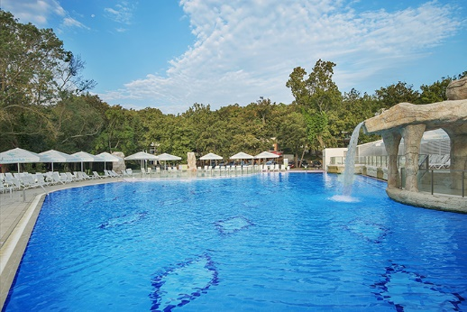

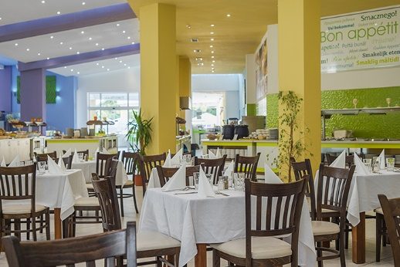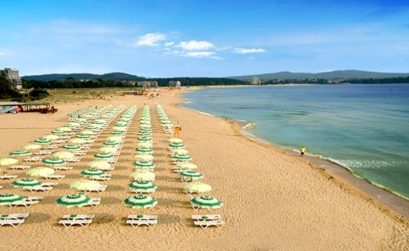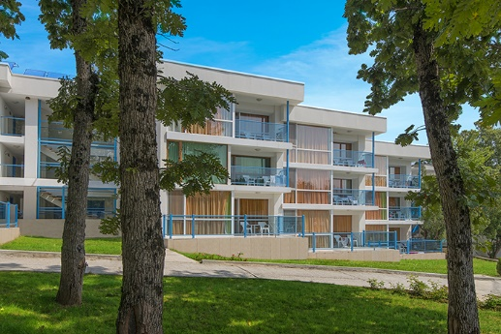Accommodation will be ALL INCLUSIVE in studios for two people. Cheaper accommodation for three people in a studio is also possible. The studios consist of two rooms - one with a bedroom and the other with a large sofa. Of course there is a bathroom and a toilet.

Single accommodation is also possible, but for a very limited number of people. Therefore, we ask all those who wish to use this option to state this **as soon as possible** to [lz3nn@abv.bg](mailto:lz3nn@abv.bg)

The conditions for ALL INCLUSIVE are described on the hotel website, but just in case, we describe the main ones:

- three meals a day + intermediate meals by request;

- free Bulgarian non-alcoholic and alcoholic drinks in the bars on the territory of the complex from 09:00 to 23:00;

- umbrella and sunbed at the designated places on the beach (until they run out).

**Fees**

BFRA accepts the starting fees approved by the ARDF Working Group, specified below.

**During 24th IARU Region 1 / European ARDF Championship (1 - 7 September 2024)**

|  |  |  |  |
| --- | --- | --- | --- |
| **Accommodation in Forest Beach Hotel\*\*\*\*** | | If paid before  20 June (in EUR) | If paid after 20 June (in EUR) |
| Starting fees for the whole event (4 starts), include transportations to start/from finish | Competitors only | 300 | 320 |
| Starting fee per person per competition, includes transportation to start/from finish | Competitors only | 75 | 80 |
| Transport cost to finish and back per person for the whole event (4 starts) | Team officials, Guests/Visitors | 32 | 40 |
| Transport cost to the finish and back per person per day | Team officials, Guests/Visitors | 8 | 10 |
| Two people in STUDIO, All-inclusive, per person per day | All participants | 57 | 65 |
|  |  |  |  |
| Three people in STUDIO, All-inclusive, per person per day | All participants | 53 | 58 |
| Single person in double room, All inclusive, per day | All participants  (competitors – if available) | 75 | 80 |
| Extra days before and after Championship, two people in STUDIO, All-inclusive, per person per day | All participants | 57 | 65 |
| Extra days before and after Championship, three people in STUDIO, All-inclusive, per person per day | All participants | 53 | 58 |
| Extra days before and after Championship, single person in double room, All inclusive, per day | All participants | 75 | 80 |

Several examples, payment **before 20 June**:

Accommodation and starting fees for **competitor** in STUDIO for double accommodation for 6 days and 4 starts – 642 EUR

Accommodation and starting fees for **competitor** in STUDIO for triple accommodation for 6 days – 618 EUR

Accommodation and transport cost for **team officials guests/visitors** in STUDIO for double accommodation for 6 days and 4 competition days – 374 EUR

Accommodation and transport cost for **team officials guests/visitors** in STUDIO for triple accommodation for 6 days and 4 competition days – 350 EUR

Accommodation and transport cost for **team officials, guests/visitors** for single accommodation for 6 days and 4 competition days – 482 EUR

Several examples, payment **after 20 June**:

Accommodation and starting fees for **competitor** in STUDIO for double accommodation for 6 days and 4 starts – 710 EUR

Accommodation and starting fees for **competitor** in STUDIO for triple accommodation for 6 days – 668 EUR

Accommodation and transport cost for **team officials guests/visitors** in STUDIO for double accommodation for 6 days and 4 competition days – 430 EUR

Accommodation and transport cost for **team officials guests/visitors** in STUDIO for triple accommodation for 6 days and 4 competition days – 388 EUR

Accommodation and transport cost for **team officials, guests/visitors** for single accommodation for 6 days and 4 competition days – 520 EUR

**Important**: Due to the limited available rooms / studios, **self-accommodation** is available **upon prior request and availability**. The fees are listed below.

|  |  |  |  |
| --- | --- | --- | --- |
| **Self-accommodation** | | If paid before  20 June (in EUR) | If paid after 20 June (in EUR) |
| Starting fees for the whole event (4 starts), include transportations to start/from finish | Competitors | 300 | 320 |
| Starting fee per competition, includes transportation to start/from finish | Competitors | 75 | 80 |
| Transport cost to finish and back per person for the whole event (4 starts) | Team officials, Guests/Visitors | 32 | 40 |
| Transport cost to the finish and back per person per day | Team officials, Guests/Visitors | 8 | 10 |
| Banquet / Hamfest | All participants | 20 | 20 |

**During with ARDF WORLD Cup Black sea 2024 (28 August- 1 September 2024)**

|  |  |  |  |
| --- | --- | --- | --- |
| **Accommodation in Forest Beach Hotel\*\*\*\*** | | If paid before  20 June (in EUR) | If paid after 20 June (in EUR) |
| Two people in STUDIO, All-inclusive, per person per day | All participants | 57 | 65 |
|  |  |  |  |
| Three people in STUDIO, All-inclusive, per person per day | All participants | 53 | 58 |
| Extra day before and after competitions, two people in STUDIO, All-inclusive, per day per person | All participants | 57 | 65 |
| Extra day before and after competitions three people in STUDIO, All-inclusive, per day per person | All participants | 53 | 58 |
| Starting fee per start | Competitors | 12 | 15 |
| Transport cost to the finish and back per person per day | Team officials, Guests/Visitors | 5 | 8 |

|  |  |  |  |
| --- | --- | --- | --- |
| **Self-accommodation** | | If paid before  20 June (in EUR) | If paid after 20 June (in EUR) |
| Starting fee per start | Competitors | 12 | 15 |
| Transport cost to the finish and back per person per day | Team officials, Guests/Visitors | 5 | 8 |

**IMPORTANT: The payments must be made to the BFRA account:**

**Bank: United Bulgarian Bank**

**Account: BG81UBBS80021413582613 (in EUR)**

**BIC: UBBSBGSF**

**Beneficiary: Bulgarian Federation of Radio Amateurs**

**Preliminary program:**

**24th IARU Region 1 / European ARDF Championship 2024**

1 September, Sunday - Arrival, Accommodation, Official opening, Team leaders meeting, International Jury meeting

2 September, Monday - Sprint, Awarding

3 September, Tuesday - Classic 1, Awarding

4 September, Wednesday – Free day, Beach time

5 September, Thursday – Classic 2, Awarding

6 September, Friday – Foxoring, Awarding, Closing ceremony, Banquet / Hamfest

7 September, Saturday – Departure

Categories: M19, M21, M40, M50, M60, M70, W19, W21, W35, W45, W55, W65, **maximum 3 competitors per team, per category**.

Ranking: Individual ranking for each category, for each competition. Team ranking for each category **only for the two classics**.

Awards: Medals and Certificates

**with ARDF WORLD Cup Black sea 2024**

28 August, Wednesday – Arrival till 14:00, Accommodation, Late afternoon – Sprint

29 August, Thursday – Classic 1, Awarding Sprint and Classic 1

30 August, Friday – Classic 2, Awarding

31 August, Saturday – Foxoring, Awarding

1 September, Sunday – Departure / Arrival for IARU R1 ARDF Championship

Categories: M19, M21, M40, M50, M60, M70, W19, W21, W35, W45, W55, W65, **unlimited number participants** from each team/country

Ranking: **Only Individual ranking** for each category, for each competition

Awards: Medals and Certificates

**Transmitters and antennas:**

Frequency allocations for 3.5 MHz competitions:

|  |  |  |  |
| --- | --- | --- | --- |
| frequency/competition | classic | sprint | foxoring |
| 3530 kHz |  | TX 1…5 | TX 1, 1F, 2, 2F |
| 3550 kHz | TX 1…5 | Spectator (S) | TX 3, 3F, 4, 4F |
| 3570 kHz |  | TX 1F … 5F | TX 5, 5F |
| 3600 kHz | Beacon | Beacon | Beacon |

Frequency allocations for 144 MHz competition:

144.500 MHz TX 1…5

144.900 MHz Beacon

Output RF Powers:

3.5 MHz Classic TX 1…5 and Beacon 5 W;

3.5 MHz Foxoring 10 mW;

3.5 MHz Sprint 1W;

144 MHz TX 1…5 and Beacon 1 W.

Antennas:

3.5 MHz Classic and Sprint – 6 m vertical and 3 counterpoises each 2.5 m;

3.5 MHz Foxoring vertical 30 cm;

144 MHz – Crossed Dipole, horizontal, 2.5 m above the terrain.

**Description of the marking devices:**

SportIdent classic system will be used.

**Forbidden areas:**

Starting from 1 May 2024 the following areas are declared forbidden for visits:

[***https://www.google.com/maps/d/edit?mid=1gsl7ql8xt525tP7pzq6SXPwWu44kRGI&usp=sharing***](https://www.google.com/maps/d/edit?mid=1gsl7ql8xt525tP7pzq6SXPwWu44kRGI&usp=sharing)

**Visa requirement**:

The citizens of the majority countries, expected to take part in the 24th IARU Region 1 / European ARDF Championship and with ARDF WORLD Cup Black sea 2024, do not need visa to enter Bulgaria. Schengen visa is valid for Bulgaria. Please check for your country in: <https://mfa.bg/en/services-travel/consular-services/travel-bulgaria/visa-bulgaria>

**BFRA will assist** as much as possible in issuing a visa to all who need it

**Covid-19 Restrictions:**

There are no restrictions in Bulgaria

**Letter of Intent:**

Please fulfill the **Letter of Intent bellow** and send it back **not later than 31 May 2024** to [bfra­_hq@hotmail.com](mailto:bfra_hq@hotmail.com) with a copy to [lz3nn@abv.bg](mailto:lz3nn@abv.bg)

**More information will be spread in Bulletin 3.**

If you have any additional questions, please, do not hesitate to ask by mail to [lz3nn@abv.bg](mailto:lz3nn@abv.bg)

**We are looking forward to meeting you in Primorsko.**

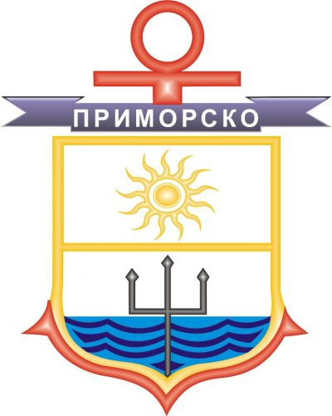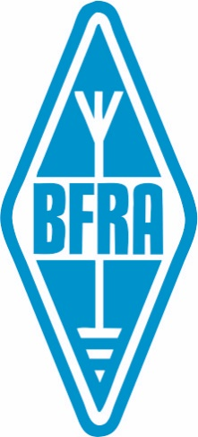**Bulgarian Federation of Radio Amateurs**





**LETTER OF INTENT**

We:

(Full name of the society) (Official abbreviation)

intend to take part in the ARDF events in Primorsko, Bulgaria as follows:

**a) 24th IARU Region 1 / European ARDF Championship 2024 (1 - 7 September 2024)**

Our delegation will consist of:

1. Number of competitors:

2. Number of officials:

3. Number of guests/visitors:

TOTAL NUMBER of participants in this event (1+2+3):

**b) with ARDF WORLD Cup Black sea 2024 (28 August - 1 September 2024).**

Our delegation will consist of:

4. Number of competitors:

5. Number of officials:

6. Number of guests/visitors:

TOTAL NUMBER of participants in this event (4+5+6):

**Contact person** regarding 24th Region 1 / European ARDF Championship 2024 and

**with ARDF WORLD Cup Black sea 2024** (responsible for the correspondence with BFRA):

Name and Family Name, Callsign:

Telephone number (including country and area codes):

E-mail:

On behalf of the society: Date:

(Name and Family name, Position in the society)